IMAGE THRESGOLDING TECHNIQUES: A SURVEY OVER CATEGORIES
Bülent Sankur^{a,*}, Mehmet Sezgin^{b}
ªBoğaziçi University Electric-Electronic Engineering Department, Bebek, İstanbul, Turkey
sankur@boun.edu.tr, Tel: +90 212 2631500, Fax: +90 212 2872465
^{b}Tübitak Marmara Research Center, Information Technologies Research Institute, Gebze, Koceli, Turkey
sezgin@btae.mam.gov.tr, Tel: +90 262 6412300/4767, Fax:+90 262 6463187
* Corresponding author

ABSTRACT
In this study we have conducted an exhaustive survey of image thresholding methods with a view to categorize them, expres them under a uniform notation, indicate their differences or similarities, and finally as a basis for performance comparison. They have been categorized into six groups according to the information they are exploiting, such as: Histogram shape-based methods, clustering-based methods, entropy-based methods, object attribute-based methods, spatial methods and local methods. In total 44 image binarization methods are summarized.

Keywords: Segmentation, binary thresholding, entropy, attribute, clustering.

1. INTRODUCTION

In many applications of image processing, the gray levels of pixels belonging to the object are quite different from the gray levels of the pixels belonging to the background. Thresholding becomes then a simple but effective tool to separate objects from the background. Examples of thresholding applications are document image analysis where the goal is to extract printed characters [1], [2], logos, graphical content, musical scores, map processing where lines, legends, characters are to be found [3], scene processing where a target is to detected [4], quality inspection of materials [5], [6]. Other applications include cell images [7], [8] and knowledge representation [9], segmentation of various image modalities for non-destructive testing (NDT) applications, such as ultrasonic images in [10], eddy current images [11], thermal images [12], X-ray computed tomography (CAT) [13], laser scanning confocal microscopy [13], extraction of edge field [14], image segmentation in general [15], [16], spatio-temporal segmentation of video images [17] etc.

The output of the thresholding operation is a binary image whose gray level of 0 (black) will indicate a pixel belonging to a print, legend, drawing, or target and a gray level of 1 (white) will indicate the background.

The main difficulties associated with thresholding such as in documents or NDT applications occur when the associated noise process is non-stationary, correlated and non-Gaussian. Other factors complicating thresholding operation are ambient illumination, variance of gray levels within the object and the background, inadequate contrast, object shape and size non-commensurate with the scene. Finally the lack of objective measures to assess the performance of thresholding algorithms is another handicap. In fact most authors limit themselves to the visual inspection of a few test cases.

A document image analysis and recognition system includes several image processing techniques, beginning with digitization of the document and ending with character recognition and natural language processing. Thresholding is one of the first low-level image processing techniques used, before document analysis step, for obtaining a binary image from its gray scale one. The thresholding step can be quite critical in that it will affect the performance of successive steps such as segmentation of the document into text objects, and the correctness of the OCR (optical character recognition). Improper thresholding causes blotches, streaks, erasures on the document confounding segmentation and recognition tasks. The merges, fractures and other deformations in the character shapes as a consequence of incorrect thresholding are known to be the main reasons of OCR performance deterioration. In turn thresholding algorithms depend on a multitude of factors such as the gray level distribution of the document, local shading effects, the presence of denser, non-text components such as photographs, the quality of the paper etc.

In NDT applications the thresholding is again often the first step in a series of processing operations such as morphological filtering, measurement and statistics assessment. While the document images form at least one category of images NDT images can derive from various modalities, with differing application goals. Thus it may be even more difficult to predict a single universal thresholding method that applies well to all NDT cases. Given the rather different nature of the document and NDT images, it is conjectured that the thresholding algorithms that apply well for, let’s say, document images are not necessarily the better performing ones for the NDT images, and vice versa.

In this study we develop taxonomy of thresholding algorithms based on the type of information used. We distinguish six categories, namely, thresholding algorithms based on the exploitation of 1) Histogram entropy information, 2) Histogram shape information, 3) Image attribute information such as contours, 4) Clustering of gray-level information, 5) Locally adaptive characteristics, 6) Spatial information.

Their performance is investigated on a comparative basis for document images in the extraction of binary character shapes from gray level documents and for NDT images in the extraction of foreground objects such as defective parts, cracks etc. on a surface or phases of metals. To address different aspects of extracted binary objects several fidelity criteria are used [18]. These criteria reflect confusion between foreground and background pixels (misclassification error, foreground area error), shape distortion (modified Hausdorff distance, edge mismatch) and region uniformity. Notice that the first four criteria need ground-truth data. The scores of these metrics are rank averaged over all test images to attain an overall quality performance figure for each thresholding method as detailed in [18].

There have been a number of survey papers on thresholding. Lee, Chung and Park [19] conducted a comparative analysis of five global thresholding methods and advanced several useful criteria for thresholding performance evaluation. In an earlier paper Weszka and Rosenfeld [20] also defined several evaluation criteria. Palumbo, Swaminathan and Srihari [21] addressed the issue of document binarization comparing three methods while Trier and Jain [3] had the most extensive comparison basis (19 methods) in the context of character segmentation from complex backgrounds. Sahoo et al. [22] surveyed nine thresholding algorithms and illustrated comparatively their performance. Glasbey [23] pointed out the relationships and performance differences between 11 histogram-based algorithms based on an extensive statistical study.

Our paper seems to be the most comprehensive survey of image thresholding methods, in that we both describe the underlying idea of the algorithms and measure their performance in different contexts. We categorize these algorithms into six categories according to the information source they are exploiting. We believe this survey is a timely effort as about 60% of the methods discussed and referenced date after the last surveys in this area [19], [23]. Furthermore their performance comparison is based not only on document processing but it involves an extensive variety of NDT (Nondestructive Testing) applications. Most authors limit their comparisons to visual assessment and/or a handful of other competitor algorithms. We use a combination of four objective criteria to assess their performance and our algorithm repertoire in the comparisons encompasses 44 methods.

The outcome of this study is envisaged to be the formulation of the large variety of algorithms under a unified notation, the identification of the most appropriate types of binarization algorithms and deduction of guidelines for novel algorithms. The structure of the paper is as follows: In sections 3 to 8 of this paper, respectively, histogram shape-based, clustering-based, entropy-based, object attribute-based, spatial information-based and finally locally adaptive thresholding methods are detailed. In section 9 some conclusions are drawn. In Part II of this study details of the comparison methodology and performance criteria are given [18] and the experimental results discussed.

2. CATEGORIES and PRELIMINARIES

We categorize the thresholding methods in six groups according to the information they are exploiting. These categories are:
1. Histogram shape-based methods where the peaks, valleys and curvatures of the smoothed histogram are analyzed.
2. Clustering-based methods where the gray level samples are clustered in two parts as background and foreground (object) or alternately are modeled as two Gaussian distributions.
3. Entropy-based methods result in algorithms, for example, that use the entropy foreground-background regions, the cross-entropy between the original and binarized image etc.
4. Object attribute-based methods search a measure of similarity between the gray-level and binarized images, such as fuzzy similarity, shape, edges, number of objects etc.
5. The spatial methods use the probability mass function models taking into account correlation between pixels on a global scale.
6. Local methods do not determine a single value of threshold but adapt the threshold value depending upon the local image characteristics.
In the sequel we use the following notation. The histogram and the probability mass function (pmf) of the image are indicated, respectively, by h(g) and by p(g), g = 0...G, where G is the maximum luminance value in the image, typically 255 if 8-bit quantization is assumed. If the gray value range is not explicitly indicated as [g_{min}, g_{max}] it will be assumed to extend from 0 to G. The cumulative probability function is defined as 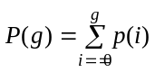. It is assumed that the pmf is estimated from the histogram of the image by normalizing to the number of samples at every gray level. In the context of document processing, the foreground (object) is the set of pixels with luminance values less than T, while the background pixels have luminance value above this threshold. In NDT images the foreground area may consists of darker (more absorbent, denser etc.) regions or conversely of shinier regions, for example that hotter, more reflective, less dense etc. regions. In contexts where the object appears brighter than the background the definitions of the foreground and background will be simply toggled.

The foreground (object) and background pmf's will be expressed as 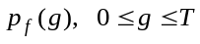, and 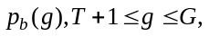 respectively, where T is the threshold value. The foreground and background area probabilities are calculated as:
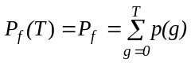 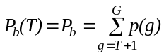 (1)
The Shannon entropy parametrically dependent upon the threshold value T for the foreground and background is formulated as:
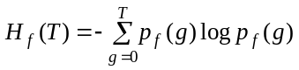 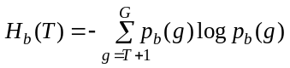 (2)
The sum of these two is expressed as 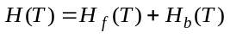. When the entropy is calculated over the input image distribution p(g) (and not over the class distributions), then obviously it does not depend upon the threshold T and hence is expressed simply as H. For various other definitions of the entropy in the context of thresholding, with some abuse of notation, we will use the same symbols of H_{f}(T) and H_{b}(T).

The fuzzy measures attributed to the background and foreground events, that is the degree to which the gray level; g, belongs to the background and object, respectively, are symbolized by 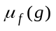 and 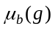). The mean and variance of the foreground and background as functions of the thresholding level T can be similarly denoted as:

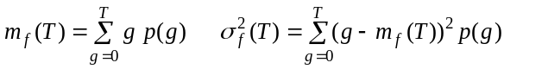 (3)
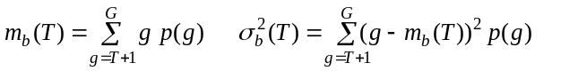 (4)

3. HISTOGRAM SHAPE-BASED THRESHOLDING METHODS

This category of methods achieves thresholding based on the shape properties of the histogram. Basically two major peaks and an intervening valley is searched for using such tools as the convex hull of the histogram, or its curvature and zero crossings of the wavelet components. Other authors try to approximate the histogram via two-step functions or two-pole autoregressive smoothing.

Shape_ Rosenfeld: Shape-based thresholding of Rosenfeld [24]
This method is based on obtaining the convex hull, Hull(g), of the pmf and analyzing the concavities of h(g) vis-à-vis the convex hull, that is the set theoretic differences |Hull(g) – p(g)|. When the convex hull of the pmf is calculated the deepest concavity points become candidates for a threshold. The selection among these concavities is based upon some object attribute feedback, such as low busyness of the thresholded image, resulting in:
(5)
Other variations on the theme are in Weszka [20] , [ 25]. We found that the deepest concavity point works best as a threshold irrespective of object smoothness. Halada and Osokov [26] have also considered histogram concavity analysis. Sahasrabudhe and Gupta [27] have addressed the histogram valley-seeking problem. More recently Whatmough [28] has improved on this method by considering the exponential hull of the histogram.

Shape_ Sezan: Shape-based thresholding of Sezan [29]
This scheme is based on the peak analysis of the smoothed histogram. To this effect a peak detection signal, r(g), is generated by the convolution of the histogram with the peak detection kernel, which is completely characterized by the smoothing parameter N (the support of the kernel) to be adjusted automatically to attain the desired number of peaks. Using a differencing operation on the smoothed kernel, the histogram is characterized by the set S of peaks, that is the triplet of incipient, peaking and terminating zero-crossings on the peak detection signal: 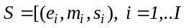, where I is the number of peaks sought. The actual number of peaks obtained is reduced to I, that is 2 for binarization, by adjusting the support of the smoothing filter and a peak-merging criterion. For two-level representation of an image the threshold should be somewhere in between the first incipient and the second terminating zero crossing, that is:
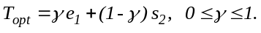 (6)
In our work we have found that 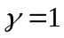 yields good results. Variations on this theme are provided in Boukharouba [30] where the cumulative distribution of the image is first expanded in terms of Tschebyshev functions followed by the curvature analysis. Tsai [31] obtains a smoothed histogram via Gaussians and the resulting histogram is investigated for the presence of both valleys and sharp curvature points. The curvature analysis becomes effective when the histogram has lost its bimodality due to the excessive overlapping of class histograms.

Shape_ Olivo: Shape-based thresholding of Carlotto [32] and Olivo [33]
Both Carlotto [32] and Olivo [33] consider the multiscale analysis of the pmf and interpret its fingerprints, that is the course of its zero crossings and extrema over the scales. In [33] using a discrete dyadic wavelet transform, one obtains a sequence of smoothed signals describing the multiresolution analysis of the histogram, 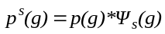 where 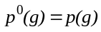 is simply the original normalized histogram. Detection of zero-crossings and the local extrema of this wavelet transform yield a complete characterization of the histogram peaks, as well as their incipient and terminating points. The threshold is defined as the valley (minimum) point following a peak in the smoothed histogram. This threshold position is first estimated at the coarsest resolution, but later refined using finer resolution representations and establishing correspondences between extrema at different resolution levels. Thus one starts with the valley point, 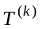 at the k'th coarse level of 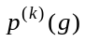. Its position is corrected and refined by backtracking from extrema of higher resolution versions 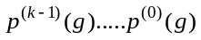, that is one arrives at 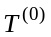using the information sequence 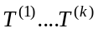 (in our work k =3 was used):
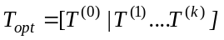 (7)

Shape_Ramesh: Shape-based thresholding of Ramesh [34]
The authors use a functional approximation to the pmf. It is approximated by two-step functions, that is, a bi-level function, in such a way that either the sum of squares or the variance of the approximation is minimized. Using the bi-level function one establishes the threshold as:
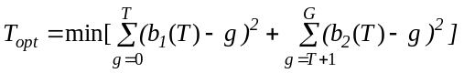, with 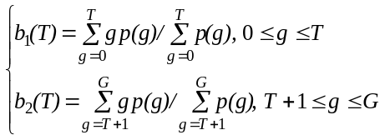 (8)
The solution 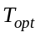 is obtained by iterative search. Kampke and Kober [35] have generalized the shape approximation idea.

Shape_Guo: Shape-based thresholding by an all-pole model Guo [36], Cai [37]
In Cai [37] the authors have approximated the spectrum as the power spectrum of multi-complex exponential signals in Prony’s spectral analysis method. A similar all-pole model was assumed in Guo [36], where the threshold is selected by maximizing the between-class variance. We have used a modified approach, where the autoregressive (AR) model is used to smooth the histogram and the valley is found by the pole analysis. Thus one interprets the pmf p(g) and its mirror reflection around g = 0, p(-g), as a noisy power spectral density. One obtains the autocorrelation coefficients at lags k = 0 ... G, by the IDFT (Inverse Discrete Fourier Transform) of the original histogram (interpreted as a power spectral density), that is 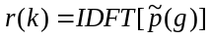 where . The symmetric and Toeplitz covariance matrix R can be similarly built. The autocorrelation coefficients {r(k)}are then used to obtain the 4th order AR coefficients {a_{i}}. The threshold is established as the minimum, resting between its two pole locations, of the resulting smoothed AR spectrum, that is:
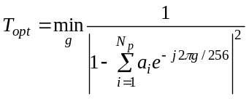where 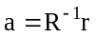 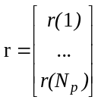 and 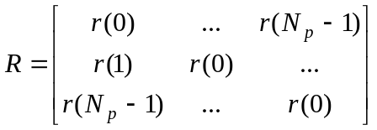 (9)
If the autocorrelation function does not contain a minimum for a specified order it is increased up to obtaining at least a minimum.
4. CLUSTERING BASED THRESHOLDING METHODS

In this class of algorithms the gray level data undergoes a clustering analysis with the number of clusters being set to two. Alternately the gray level distribution is modeled as a mixture of two Gaussian distributions representing, respectively, the background and foreground regions.

Clustering_ Riddler: Iterative thresholding of Riddler [38], Leung [39], Trussel [40]
This method was one of the first iterative schemes based on two-class Gaussian mixture models. At iteration n, a new threshold T_{n} is established using the average of the foreground and background class means:
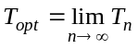 where 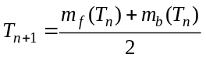 (10)
In practice, however, iterations terminate when the change |T_{n} - T_{n+1} | becomes sufficiently small.

Clustering_Otsu: Clustering thresholding of Otsu [41]
Otsu suggested minimizing the weighted sum of within-class variances of the foreground and background pixels to establish an optimum threshold. Since minimization of within-class variances is tantamount to the maximization of between-class scatter, the choice of the optimum threshold can be formulated as:
(11)
The Otsu method gives satisfactory results when the numbers of pixels in each class are close to each other. The Otsu method still remains one of the most referenced thresholding methods. In a similar study thresholding based on isodata clustering is given in Velasco [42]. Some limitations of the Otsu method is discussed in Lee [43].
Clustering_Lloyd: Minimum error thresholding of Lloyd [44]
It is assumed that the image can be characterized by a mixture distribution of foreground and background pixels: 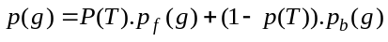. Under the assumption of equal variance Gaussian density functions, the threshold that minimizes the total misclassification error becomes:
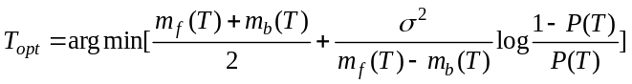 (12)
where 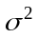 is the variance of the whole image. The minimum of the above expression that yields the optimum threshold can be found via an iterative search.

Clustering_Kittler: Minimum error thresholding of Kittler [45], Cho [46], Kittler [47]
In this method the foreground and background class conditional probability density functions are assumed to be Gaussian, but in contrast to the previous method the equal variance assumption is removed. The error expression can be interpreted also as a fitting error expression to be minimized such that:
(13)
where 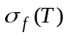 and 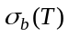 are, respectively, the foreground and background variances for each choice of T. Recently Cho, Haralick and Yi [46] have suggested an improvement of this thresholding method by observing that in the original scheme the means and variances are estimated from truncated distributions resulting in a bias. This bias becomes noticeable, however, whenever the two histogram modes are not distinguishable. In our experiments we have observed that the peaks were distinguishable, hence we preferred the algorithm in Kittler [45].

Clustering_Yanni: Clustering thresholding of Yanni [48]
This method assumes that two distinct peaks at gray levels 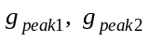 are identifiable in the pmf. A midpoint is first established as 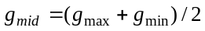 where 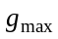 is the highest nonzero gray level and 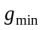 is the lowest one. This midpoint is updated using the mean of the two peaks on the right and left of, that is as 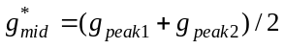. The threshold is then
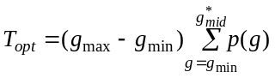 (14)
where 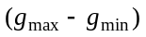 is the span of non-zero gray values in the histogram.

Clustering_ Jawahar: Clustering thresholding of Jawahar [49]
In this fuzzy clustering memberships are assigned to pixels depending on the difference of their gray value from the class means. Such a fuzzy partitioning may reflect the structural details and the identities of the pixels embedded in the gray level distribution, as opposed to what occurs, for example in the K-means clustering. The cluster means and membership functions are calculated as:
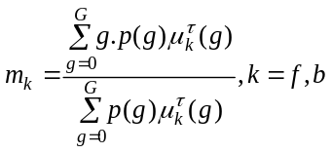, 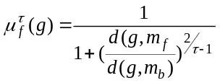 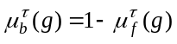 (15)
In these expressions d(. , .) is the Euclidean distance function between the gray value g and the class mean, while is the fuzzyness index. Notice that for 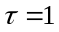 one obtains the K-means clustering. In our experiments we used 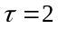. In a second method proposed by them the distance function and the membership function are defined as [34] :
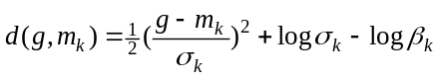, 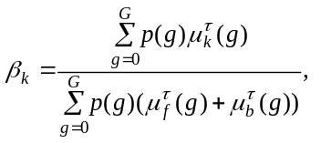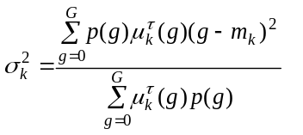 (16)
Where k=f,b. In either method based on the two distance functions the threshold is established as the cross-over point, i.e.,
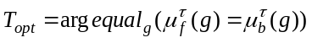 (17)
In Part II of this study [18] Jawahar_a and Jawahar_b refers to the above first and second definitions, respectively.

5. ENTROPY-BASED THRESHOLDING METHODS

This class of algorithms exploits the entropy of the distribution of the gray levels in a scene. The maximization of the entropy of the thresholded image is interpreted as indicative of maximum information transfer. Other authors try to minimize the cross-entropy between the input gray-level image and the output binary image as indicative of preservation of information. Johannsen and Bille [50] and Pal, King, Hashim [51] were the first to study Shannon entropy based thresholding.
Entropy_Pun: Entropic thresholdings of Pun [52], Pun [53]
Pun considers the gray level histogram as a G-symbol source where all the symbols are statistically independent. The ratio of the a posteriori entropy as a function of the threshold T to that of the source entropy 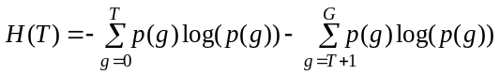 is lower bounded by 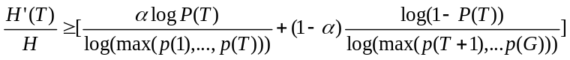. The optimal threshold in the Pun sense is calculated by solving for :
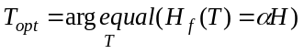 (18)
where the parameter is the one that maximizes the lower bound stated above, and H_{f}(T) is the entropy of the object (foreground) pixels. In the second method of Pun [53] anisotropy parameter is defined depending on the histogram asymmetry and optimal threshold value is given in the following equation
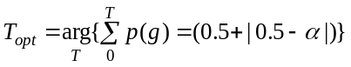 (19)
In Part II of this study [18] Pun_a and Pun_b refer to the above first and second definitions, respectively.

Entropy_Kapur: Entropic thresholding of Kapur [54]
In this method the foreground and background classes are considered as two different sources. When the sum of the two class entropies is a maximum the image is said to be optimally thresholded. Thus using the definitions of the foreground and background entropies, 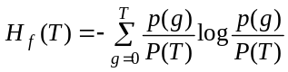 and 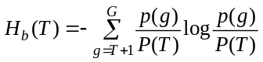 one has:
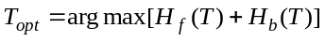 (20)
Yen, Chang and Chang [55] have considered a multilevel thresholding scheme where in addition to the class entropies a cost function based on the number of bits needed to represent the thresholded image is included.

Entropy_Li: Cross-entropic thresholding of Li [56], Li [57]
In this method the threshold determination is formulated as a constrained maximum entropy inference problem. The constraint forces the total intensity in the reconstructed image to be identical to that in the observed image in both the foreground and background regions. As a measure of similarity between the original image and the processed (thresholded) image one considers 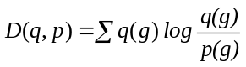, which is the information theoretic distance between the two distributions p(g) and q(g). It is shown that the minimum cross-entropy formulation becomes:
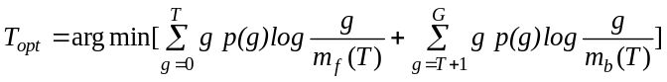 (21)
under the constraint that the original image and the thresholded image have the same average intensity in their foreground and background regions, expressed as 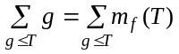 and 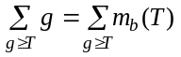.

Entropy_Shanbag: Entropic thresholding of Shanbag [58]
Shanbag has considered a thresholding method that relies on a fuzzy membership coefficient, which indicates how strongly a gray value belongs to the background or to the foreground. The membership value is based on the cumulative probability of that gray value. In fact the farther away a gray value is from a presumed threshold, the greater is its potential to belong to a specific class. Thus for any foreground and background pixel, which is, i level below or above a given threshold T the membership values are determined by
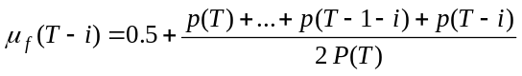, that is its measure of belonging to the foreground, and by 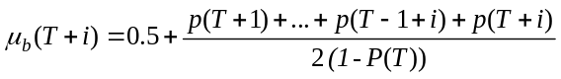, respectively. Obviously on the gray value corresponding to the threshold one should have the maximum uncertainty, such that 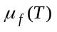= 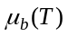= 0.5. The optimum threshold is found as
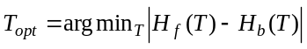 (22)
since one wants to get equal information for both the foreground and background. In this expression the class entropies, as a function of T, are defined as
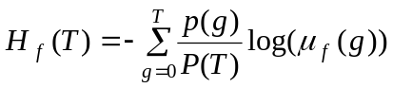,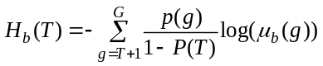 (23)

Entropy_Yen: Entropic thresholding of Yen [55]
This method corresponds to the special case of the following method (Entropy_Sahoo) utilizing ρ=2. The optimal threshold value is given as the following “entropic correlation” equation 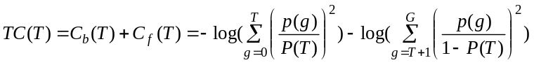, thus:
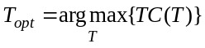 (24)

Entropy_Brink: Cross-entropic thresholding of Brink [59]
Brink and Pendock suggest that a threshold be selected to minimize the cross-entropy defined as
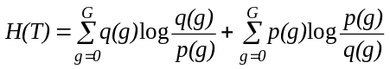. The cross-entropy is interpreted as a measure of data consistency between the original and the binarized images. It can be shown that the optimum threshold can also be found by maximizing an expression in terms of class means, that is,
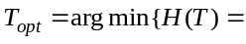 (25)

Entropy_Sahoo: Entropic thresholding of Sahoo [60]
These authors combine the results of three different threshold values, namely those in references Kapur [54] , and Yen [55] . The Renyi entropy of the foreground and background sources for some parameter are defined as: 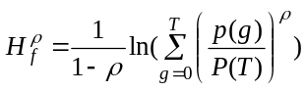 and 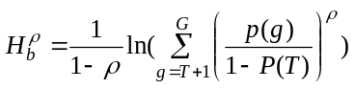. Sahoo et al. [60] have found three different threshold values, namely T₁, T₂, T₃ by maximizing the sum of the foreground and background Renyi entropies for the three ranges of , 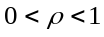 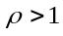 and 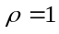, respectively. For example T₂ for corresponds to the Kapur [54] threshold value, while for the threshold corresponds to that found in Yen [55].
Using T₁, T₂, and T₃ threshold values an “optimum” T value is found by rank ordering and weighting them as follows:
(26)
In this expression T _{[1]}, T _{[2]}, and T _{[3]} are the rank ordered T₁, T₂ and T₃ thresholds, while 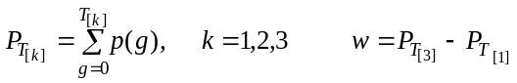 and finally B₁ B₂ B₃ weights are given as follows:
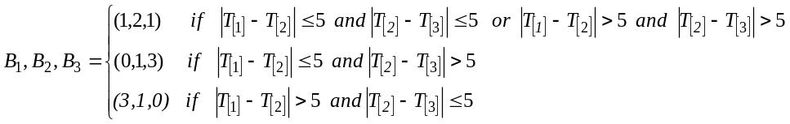 (27)
The optimal threshold can be considered to be an image dependent weighted average of T₁, T₂, and T₃.

Entropy_Pal: Cross-entropic thresholding of Pal [61]
A variation of this cross-entropy approach is given by specifically modeling the a posteriori probability mass functions (pmf) of the foreground and background regions. Using the Maximum Entropy principle in Shore [62] , the corresponding pmf’s are defined as
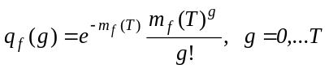, 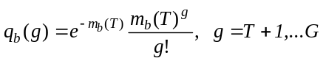 (28)
Thus the optimum threshold T_{opt} is found by maximizing the cross-entropy expression with respect to T:
(29)
Wong and Sahoo [63] have presented a former study of thresholding based on maximum entropy principle.

Entropy_Sun: Entropic thresholding of Cheng [64]
This method of thresholding relies on the maximization of fuzzy events. These fuzzy events are generated by the foreground A_{f} and background A_{b} subevents. The membership function is assigned using Zadeh’s S-function, Kaufmann [65], parametrically defined in terms of a, b, c, as:
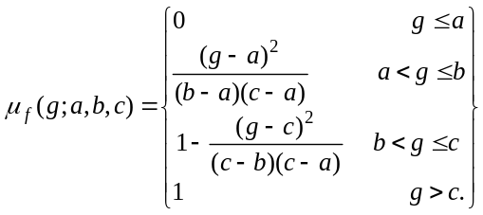 (30)
The entropy of the fuzzy event is then defined, with where 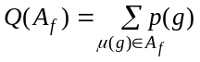 and 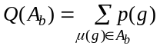 as 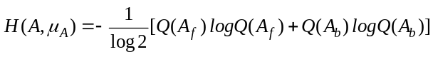 In other words 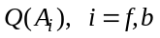 corresponds to the probabilities summed in the g domain for all gray values mapping into the sub-event. One maximizes the entropy of the fuzzy event over the parameters (a, b, c) of the S-function. The threshold T is the value g satisfying the partition for 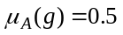.

6. THRESHOLDING ALGORITHMS BASED ON ATTRIBUTE SIMILARITY

The algorithms considered under this category select the threshold value based on some similarity measure between the original image and the binarized version of the image. These attributes can take the form of edges, shapes, or one can directly consider the original gray-level image to binary image resemblance. Alternately they consider certain image attributes such as compactness or connectivity of the objects resulting from the binarization process or the coincidence of the edge fields.

Attribute_Tsai: Moment Preserving Thresholding of Tsai [66], Cheng [67]
Tsai considers the gray-level image as the blurred version of an ideal binary image. The thresholding is established so that the first three gray-level moments match the first three moments of the binary image. The gray-level moments, m_{k}, and binary image moments, b_{k}, are defined, respectively as: 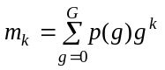 and 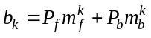 The threshold then is given by:
(31)
Cheng and Tsai [67] reformulate this algorithm based on neural networks. Delp and Mitchell [68] have extended this idea to quantization.

Attribute_Hertz: Edge field matching thresholding of Hertz [69]
Hertz and Schafer [69] consider a multithresholding technique where an initial global threshold estimate is refined locally by considering edge information. The method assumes that a thinned edge field is obtained from the gray-level image E_{gray}, which is compared with the edge field derived from the binarized image, E_{binary}(T). The threshold is adjusted in such a way that the coincidence between theses two edge fields is maximized. This implies there is minimum allowance for either excess edges and missed edges. In our case we have considered a simplified version of this approach. Both the gray-level image edge field and the binary image edge field have been obtained via the Sobel operator. The global threshold is given by that value that maximizes the coincidence of the two edge fields based on the count of matching edges and penalizing the excess original edges and the excess thresholded image edges.
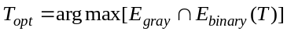 (32)
In a complementary study Venkatesh and Rosin [14] have addressed the problem of optimal thresholding for edge field estimation.

Attribute_Ogorman: Connectivity preserving thresholding of O’Gorman [70]
Most global thresholding methods tries to find a threshold value using a criterion function which uses the histogram of the image. But this method, proposed by O'Gorman [70] , is based on connectivity rather than intensity. Thresholds are found that preserve connectivity within regions. Since connectivity is a local measure, and since it is measured throughout the entire image, this is a global thresholding method based on a local measure. The method has three general steps: 1) Determination of the runlength histogram at each thresholding value; 2) Determination of the sliding profile, that is the conversion from the runs histogram to a smoothness and lack of flatness curve, 3) Determination of thresholds corresponding to the peaks of the sliding profile. For binarization only the maximum of such peaks is found so that:
(33)

Attribute_Huang: Fuzzy similarity thresholding of Huang [71]
Fuzzy set theory has been applied to image thresholding to partition the image space into meaningful regions. Murthy and Pal [72] discussed the mathematical framework for fuzy thresholding. The index of fuzziness often is obtained by measuring the distance between the gray-level image and its crisp (binary) version. The image set is then represented as 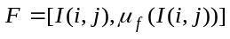, where 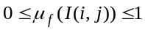 represents for each pixel at location (i,j) its fuzzy measure to belong to the foreground. Thus the fuzziness measure can be defined in terms of class (foreground, background) medians or means m_{f}(T), m_{b}(T):
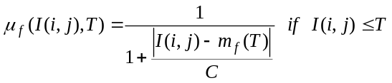 , 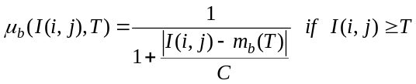 (34)
where C is a constant value such as to render 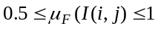. For example C can be chosen as g_{max} – g_{min} or simply as G. Given the fuzzy membership value for each pixel, an index of fuzziness for the whole image can be obtained via the Shannon entropy or the Yager’s measure [73]. The former definition has been shown to yield better results. Obviously the smaller the total measure of fuzziness the better is the binarization, so that:
(35)
Ramar et al. [74] have evaluated various fuzzy measures for threshold selection, namely linear index of fuzziness, quadratic index of fuzziness, logarithmic entropy measure, and exponential entropy measure, concluding that linear index works best.

Attribute_Pikaz: Topological stable state thresholding of Pikaz [75]
In this method offered by Pikaz and Averbuch [75] , the objective is to binarize the image while establishing the correct size foreground objects. It has been noted in Russ [7] that experts in microscopy subjectively adjust the thresholding level at a point where the edges and shape of the object get stabilized. This is instrumented via the size-threshold function N_{s}(T), parametrically dependent upon the object size. The s-object is defined as the number of objects that have at least s number of pixels. Thus the N_{s}(T) function simply calculates, for a given object size s (e.g., objects containing at least 1000 pixels) the number of such objects. The threshold is established in the widest possible plateau of the graph of the N_{s}(T) function. Since noise objects rapidly disappear with the shifting of the threshold, the plateau in effect reveals the threshold range for which the objects are easily distinguished from the background and are also stable. Any threshold that is in the widest plateau can be chosen as an optimum threshold value. We chose the middle value of the largest size versus threshold plateau as the optimum threshold value.
(36)

Attribute_Leung: Maximum information thresholding of Leung [76]
Leung and Lam define the thresholding problem as the change in the uncertainty of an observation when the foreground and background classes are specified. In the absence of any observation the scene entropy is measured by where is the probability of a pixel to belong to the foreground (object) while 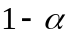 is the probability to belong to the background. In the presence of information this uncertainty amount should be reduced. In fact, if the gray-scale image value g has been observed the information gain (GII) is given by: = . Finally the segmented image information (SII) can be defined, for a given segmentation map, H(g|S) is interpreted as the average residual uncertainty about which class a pixel belongs after the segmented image S has been observed:
(37)
where 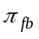 is defined as . In other words 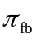 represents false alarm probability while 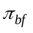 corresponds to the miss probability. The optimum threshold corresponds to the maximum decrease in uncertainty, or the segmented carrying as close a quantity of information as in the original information.
Attribute_Pal: Enhancement of fuzzy compactness thresholding of Pal [77], Rosenfeld [78]
The concept of fuzzy geometry has been generalized by Rosenfeld in [78]. For example the area and perimeter for a fuzzy set have been defined as 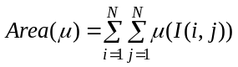 and
(38)
where the summation is taken over any region of non-zero membership. Both the perimeter and area are, of course, functions of the threshold T. Finally the optimum threshold is determined to maximize the compactness of the segmented foreground sets as:
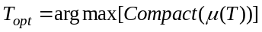 (39)
where compactness is defined as 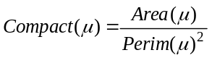. In practice one can use the standard S-function for the membership function assignment: 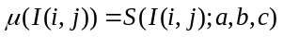, Kaufmann [65], with crossover point 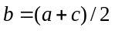 and bandwidth 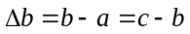. Thus one selects a crossover point b = g and a bandwidth 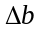and calculates the compactness of the thresholded set. The optimum threshold T is found by exhaustively searching over the (b, ) pairs to minimize the compactness figure. Obviously the advantage of the compactness measure over other indexes of fuzziness is that the geometry of the objects or fuzziness in the spatial domain is taken into consideration.

Other studies involving image attributes are as follows. In the context of document image binarization Liu and Srihari [79] Liu et al. [80] have considered document image binarization based on texture analysis while Don [81] has taken into consideration noise attribute of images. Guo [82] develops a scheme based on morphological filtering and fourth order central moment. Solihin and Leedham [83] have developed a global thresholding method to extract handwritten parts from low-quality documents. In another interesting approach Aviad and Lozinskii [84] have introduced semantic thresholding to emulate human approach to image binarization. The "semantic" threshold is found by minimizing measures of conflict criteria so that the binary image resembles most to a "verbal" description of the scene. Gallo and Spinello [85] have developed a technique for thresholding and iso-contour extraction using fuzzy arithmetic. Fernandez [86] has investigated the selection of a threshold in matched filtering applications in the detection of small target objects. In this application the Kolmogorov-Smirnov distance between the background and object histograms is maximized as a function of the threshold value.

7. SPATIAL THRESHOLDING METHODS

In this class of algorithms one utilizes spatial information of object and background pixels, for example, in the form of context probabilities, correlation functions, co-occurrence probabilities, local linear dependence models of pixels, two-dimensional entropy etc. One of the first to explore spatial information was Rosenfeld [87] who considered such ideas as local average gray level for thresholding. Other authors have used relaxation to improve on the binary map as in [88], [89] , the Laplacian of the images to enhance histograms [25], the quadtree thresholding [90], and second-order statistics [91]. Co-occurrence probabilities have been used as indicator of spatial dependence as in Lie [92], Pal [93], Chang [94]. Recently Leung and Lam have considered thresholding in the context of a posteriori spatial probability estimation [95].

Spatial_Pal: Spatial thresholding methods of Pal [93]
Pal [93] realizes that two images with identical histograms can yet have different n’th order entropies. Thus he considers the co-occurrence probability of the gray valued image over horizontal and vertical neighbors. In other words the co-occurrence of gray levels k and l as a function of threshold T is calculated as 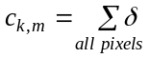 where and . Pal proposes to use the co-occurrence probabilities to define the two entropy expressions, namely:
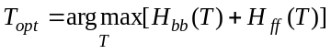 (40)
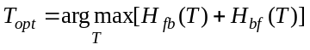 (41)
In the first expression we force the binarized image to have as many background-to-foreground and foreground-to-background transitions as possible. In the second approach the converse is true in that the probability of the neighboring pixels staying in the same class is rewarded. In Part II of this study [18] Pal_a and Pal_b refers to the above first and second definitions, respectively.

Spatial_Abutaleb: Spatial Thesholding Based on Two-Dimensional Entropy of Abutaleb [96]
Abutaleb [96] introduces the spatial information in the entropy-based thresholding by considering the joint entropy of two related random variables, namely, the image gray value, g, at a pixel and the average gray value, , of a neighborhood centered at that pixel. Using the two-dimensional histogram 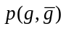, for any threshold pair 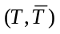, one can define the foreground entropy as 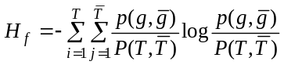. Similarly one can define the background region second order entropy. Under the assumption that the off-diagonal terms, that is the two quadrants 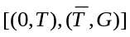 and 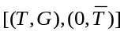 are negligible and contain elements only due to image edges and noise, the optimal pair can be found as the minimizing value of the functional:
(42)
In Wu [10] a fast recursive method is suggested to search for the pair. Cheng [97] has presented a variation of this theme by using fuzzy partitioning of the two-dimensional histogram of the pixels and their local average. Li, Gong and Chen [98] have investigated Fisher linear projection of the two-dimensional histogram. Brink [99] has modified Abutaleb's expression by redefining class entropies and finding the threshold as the value that maximizes the minimum (maximin) of the foreground and background entropies. More explicitly:
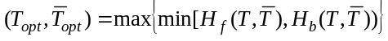 (43)

Spatial_Chang: Spatial Thresholding Based on Similarity of Co-occurrence Matrices, Chang [94]
Chanda and Majumder [100] had suggested the use of co-occurrences for threshold selection. Lie [92] has proposed several measures to this effect. In the method by Chang, Chen, Wang and Althouse the co-occurrence probabilities of both the original image and of the thresholded image are calculated. An indication that the thresholded image is most similar to the original image is obtained whenever they possess as similar co-occurrences as possible. In other words the threshold T is determined in such a manner that the gray level transition probabilities of the original image has minimum relative entropy (discrepancy) with respect to that of the original image. This measure of similarity is obtained using the relative entropy, alternatively called the directed divergence or the Kullback-Leibler distance, which for two generic distributions p, q has the form 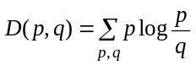. Consider the four quadrants of the co-occurrence matrix: The first quadrant denotes the background-to-background (bb) transitions while the third quadrant corresponds to the foreground-to-foreground (ff) transitions. Similarly the second and fourth quadrants, denote, respectively, the background-to-foreground (bf) and the foreground-to-background (fb) transitions. Letting the cell probabilities be denoted as p_{ij}, which is the i to j gray level transitions normalized by the total number of transitions. The quadrant probabilities are obtained as: 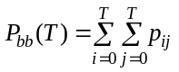, 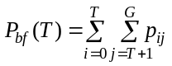, 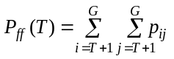, 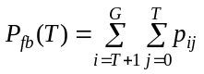 and similarly for the thresholded image one finds the quantities Q_{bb}(T), Q_{bf}(T), Q_{ff}(T), Q_{fd}(T). Plugging these expressions of co-occurrence probabilities in the relative entropy expression one can establish an optimum threshold as:
(44)

Spatial_Beghdadi: Spatial Thresholding Based on the Entropy of a Block Source Model, Beghdadi [101]
Beghdadi et al. [101] exploit the spatial correlation of the pixels without using higher order entropy by defining another source symbol, i.e., block configurations. For any threshold value, T, the image can be viewed as a set of juxtaposed binary blocks of size s×s pixels where original gray levels g_{ij} are turned into either black or white according to T. One has clearly 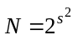possible binary block configurations. Letting B_{k} represent a subset of (s×s) blocks containing k whites and K-k blacks, the binary source probabilities 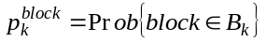 are calculated. Here 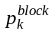 represents probability of block containing k (0 ≤ k ≤ sxs) whites irrespective of the binary pixel configurations. Notice that different configurations of blocks containing the same number of black pixels are considered as the occurrence of the same source symbol. An optimum gray-level threshold is found by maximizing the entropy function:
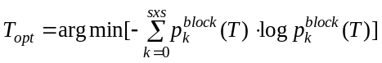 (45)
The choice of the block size is a compromise between image detail and computational complexity. As the block size becomes large, the number of configurations increases rapidly; on the other hand small blocks may not be sufficient to describe the geometric content of the image. The best block size is determined by searching over 2x2, 4x4, 8x8 and 16x16 block sizes.

Spatial_Friel: Spatial Thresholding Based on Random Sets, Friel [102]
This thresholding approach is based on the best approximating distance function of the image thresholded at gray value T to the expected distance function. The underlying idea in the method is that each gray-scale image gives rise to the distribution of a random set. In the thresholding context each choice of the threshold value generates a set of binary objects with differing distance property. Thus the expected distance function at a pixel location (i,j), 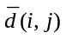, is obtained by averaging the distance maps, 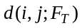, for all values of the threshold values from 0 to G, or alternately by weighting them with the corresponding histogram value. In this expression 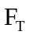denotes the binary object (the foreground according to the threshold T). Then for each value of T the 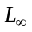 norm of the ‘signed’ difference function between the average distance map and the individual distance maps corresponding to threshold values is calculated. Thus the threshold is defined as that gray value that generates a foreground map most similar in their distance maps to the distance averaged foreground. For the norm this becomes:
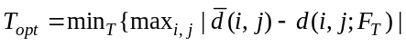 (46)

Spatial_Cheng: Spatial Thresholding Based on the Entropy of Two-D Fuzzy Partitioning, Cheng [103]
Cheng and Chen [103] combine the ideas of fuzzy entropy and the two-dimensional histogram of the pixel values and their local 3x3 averages. Given a 2D histogram it is partitioned into fuzzy dark and bright regions according to the S-function given also in Kaufmann [65]. The pixels x_{i} are assigned to A (i.e., background or foreground) according to the fuzzy rule 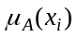, which in turn characterized by the three parameters (a,b,c). In order to determine the best fuzzy rule the Zadeh’s fuzzy entropy formula is used, where x and y are, respectively, pixel values and pixel average values, 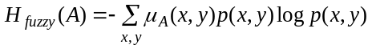 where A can be foreground and background events. For any given fuzzy rule denoted by the triple (a,b,c) the threshold is selected as the crossover point which has membership 0.5 implying the largest fuzziness. The optimum threshold is established by exhaustive searching over all permissible (a,b,c) using genetic algorithm. Thus one has:
(47)
Brink [104], [105] has considered the concept of spatial entropy that indirectly reflects the co-occurrence statistics. The spatial entropy is obtained using the two-dimensional pmf p(g, g’) where g and g’ are two gray values occurring at a lag , and where the spatial entropy is the sum of bivariate Shannon entropy over all possible lags.

8. LOCALLY ADAPTIVE THRESHOLDING METHODS

A threshold that is calculated at each pixel characterizes this class of algorithms. The value of the threshold depends upon some local statistics like range, variance, and surface fitting parameters or their logical combinations. It is typical of locally adaptive methods to have several, (e.g., 5 parameters in [106]) adjustable parameters. The threshold T(i, j) will be indicated as a function of the coordinates i, j; otherwise the object or background decisions at each pixel will be indicated by the logical variable B(i, j) . Nakagawa and Rosenfeld [107], Deravi and Pal [108] were the early users of adaptive techniques for thresholding .

Local_ Yasuda: Local thresholding of Yasuda [106]
The method first expands the dynamic range of the image followed by a nonlinear smoothing which preserves the sharp edges. The smoothing consists in replacing each pixel by the average of its eight neighbors provided the local pixel range (defined as the span between the local maximum and minimum values) is below a threshold T₁. An adaptive threshold is applied whereby any pixel value is attributed to the background (i.e., set to 255) if the local range is below a threshold T₂ or the pixel value is above the local average, both computed over bxb windows. Otherwise the dynamic range is expanded accordingly. Finally the image is binarized by declaring a pixel to be an object pixel if its mimimum over a 3x3 window is below T₃ or its local variance is above T₄. Thus:
(48)
According to [1] the parameter settings of T₁ = 50, b=16, T₂ = 16, T₃ 128, T₄ = 35 are adequate.

Local_White: Nonlinear dynamic window thresholding of White [109]
In this approach one compares the gray value of the pixel with the average of the gray values in some neighborhood about the pixel chosen to be approximately character-size. If the pixel is significantly darker than the average, it is assigned as character; otherwise it is classified as background. The method needs two parameters, one is estimate of the character within which gray values will be averaged, 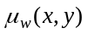, and the other is a bias value. The binarization rule is as follows:
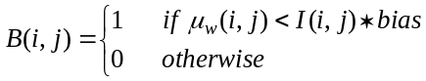 (49)
where bias factor is chosen as bias = 2 and the window size is w = 15. A comparison of various local adaptive methods, including White and Rohrer’s, can be found in Wenkateshwarluh [110] .

Local_Niblack: Local thresholding of Niblack [111]
This method adapts the threshold according to the local mean and standard deviation over a window size of bxb. The threshold at pixel (i,j) is calculated as:
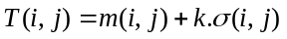 (50)
where m(i,j) and 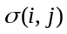 are the local sample mean and variance, respectively. In Trier [3] a window size of b = 15 and a bias setting of k = -0.2 were found satisfactory.

Local_ Bernsen: Local thresholding of Bernsen [112]
In this local method the threshold is set at the midrange value, that is at the mean of the minimum and maximum of a local window. Thus one has:
(51)
where w is a window of size bxb around the center point (i,j). However if the contrast 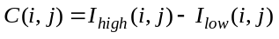 is below a certain threshold (this contrast threshold was 15) then that neighborhood is said to consist only of one class, print or background, depending upon the value of T(i,j). The window size is chosen as w = 31.

Local_Palumbo: Local thresholding of Palumbo [21] , Giuliano [113]
This algorithm based on an improvement of a method in Giuliano [113] , consists in measuring the local contrast in a 5x3x3 neighborhood of each pixel. The immediate 3x3 neighborhood A₁ of the pixel is supposed to capture the foreground (background) while the four 3x3 neighborhoods, called in ensemble A₂, diagonally adjacent to A₁ capture the background (foreground). The algorithm consists in a two-tier analysis: If I(i,j) < T₁, then B(i,j) =1. Otherwise one computes the average a₂ of those pixels in A₂ that exceed another threshold T₂ and compares it with the average a₁ of the A₁ pixels. The test for the remaining pixels consists of the inequality: If 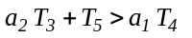then B(i,j) = 1. In Palumbo [21] the following threshold values have been suggested: T₁ = 20, T₂ = 20, T₃ = 0.85, T₄ = 1.0, T₅ = 0.

Local_Yanowitz: Surface fitting thresholding of Yanowitz [114]
This method is based on the combined use of edge and gray-level information to construct a threshold surface. The image gradient magnitude is obtained and it is thinned to yield local gradient maxima. The threshold surface is constructed by interpolation with potential surface functions using successive over-relaxation method. The threshold is obtained as:
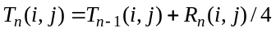 (52)
where R(i,j) is the discrete Laplacian of the surface. A recent version of surface fitting by variational method is provided by Chan, Lam, Zhu [115]. Shen and Ip [116] used a Hopfield neural network for an active surface paradigm. There have been several other studies for local thresholding specifically for badly illuminated images as in Parker [117]. Other local methods involve Hadamard multiresolution analysis [118], foreground and background clustering Savakis [119], joint use of horizontal and vertical derivatives Yang [120] .

Local_Kamel: Local thresholding of Kamel [1]
The idea in this method is to compare the average gray value in areas proportional to object width (e.g., stroke width of characters) to that of their surrounding areas. If b is the estimated stroke width, averages are calculated over a wxw window where w = 2b+1. Let L(i,j) be the comparison operator
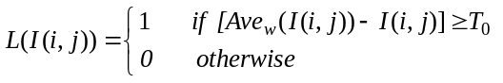 (53)
The image is then binarized according to the rule 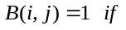
(54)
and 0 otherwise. This comparison is somewhat similar to smoothed directional derivatives. The following settings have been found appropriate for these parameters: b = 8, T₀ =40. Recently Yang and Yan have improved on the method of Kamel and Zhao by considering various special conditions Yang [121] .
Local_Oh: Indicator kriging method of Oh [13]
This method is a two-pass algorithm. In the first pass using an established non-local thresholding method such as Kapur [36] the majority of the pixel population is assigned to its two classes (object and background). Using a variation of Kapur’s technique, a lower threshold T₀ is established below which gray values are surely assigned to class 1, e.g., object. A second higher threshold, T₁ , is found such that any pixel with gray value g > T₁, is assigned to class 2, e.g., background. The remaining undetermined pixels with gray values T₀ < g < T₁, are left to the second pass. In the second pass, called the indicator kriging stage, these pixels are assigned to Class 1 or Class 2 using local covariance of the class indicators and the constrained linear regression technique called kriging.

Local_ Sauvola: Local thresholding of Sauvola [122]
This method claims to improve on the Niblack method especially for stained and badly illuminated documents. It adapts the threshold according to the local mean and standard deviation over a window size of bxb. The threshold at pixel (i,j) is calculated as:
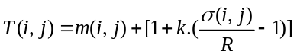 (55)
where m(i,j) and 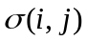are as in Niblack [59], and Sauvola suggests the values of k = 0.5 and R = 128. Thus the contribution of the standard deviation becomes adaptive. For example in the case of text printed on a dirty or stained paper the threshold is lowered.

Among other local thresholding methods specifically geared to document images one can mention the work of Kamada and Fujimoto [123] who develop a two-stage method, the first being a global threshold, followed by a local refinement. Eikvil, Taxt and Moen [124] consider a fast adaptive method for binarization of documents while Pavlidis [125] uses the second-derivative of the gray-level image. Zhao and Ong [126] have considered validity-guided fuzzy c-clustering to provide thresholding robust against illumination and shadow effects.

9. CONCLUSION

We have conducted a thorough survey of thresholding algorithms. To understand parallelisms and complementarities between the various methods we have found it convenient to categorize them into six classes on the basis of information they are exploiting. Notice that only bilevel thresholding algorithms are considered in this study, as their extension to multilevel thresholding and their performance comparisons deserve a further separate study. This review forms the basis for several studies, as for example their performance assessment in different tasks as in [18].

10. REFERENCES
1 | M.Kamel, A. Zhao, Extraction of Binary Character/Graphics Images From Grayscale Document Images, Graphical Models and Image Processing, 55, No.3 (1993) 203-217.
2 | T. Abak, U. Barış B. Sankur, The Performance of Thresholding Algorithms for Optical Character Recognition, Int. Conf. on Document Analysis and Recognition: ICDAR’97, Ulm., Germany, 1997, pp:697-700.
3 | O.D. Trier, A.K. Jain, Goal-directed evaluation of binarization methods, IEEE Tran. Pattern Analysis and Machine Intelligence, PAMI-17 (1995) 1191-1201.
4 | B. Bhanu, Automatic Target Recognition: State of the Art Survey, IEEE Transactions on Aerospace and Electronics Systems, AES-22 (1986) 364-379.
5 | M. Sezgin, R. Tasaltin, A new dichotomization technique to multilevel thresholding devoted to inspection applications, Pattern Recognition Letters, 21 (2000) 151-161.
6 | M. Sezgin, B. Sankur, Comparison of thresholding methods for non-destructive testing applications, accepted for IEEE ICIP’2001, International Conference on Image Processing, Thessaloniki, Greece October 7-10, 2001.
7 | J.C. Russ, Automatic discrimination of features in gray-scale images, Journal of Microscopy, 148(3) (1987) 263-277.
8 | M.E. Sieracki, S.E. Reichenbach, K.L. Webb, Evaluation of automated threshold selection methods for accurately sizing microscopic fluorescent cells by image analysis, Applied and Environmental Microbiology, 55 (1989) 2762-2772.
9 | P. Bock, R.Klinnert, R. Kober, R.M. Rovner, H. Schmidt, “Gray-scale ALIAS”, IEEE Trans. on Knowledge and Data Processing, 4 (1992) 109-122.
10 | L.U. Wu, M.A. Songde, L.U. Hanqing, An Effective Entropic Thresholding for Ultrasonic Imaging, ICPR’98: Int. Conf. on Pattern Recognition, Australia, 1998 pp:1522-1524.
11 | J. Moysan, G. Corneloup, T. Sollier, Adapting an ultrasonic image threshold method to eddy current images and defining a validation domain of the thresholding method, NDT&E International, 32 (1999) 79-84.
12 | J.S. Chang, H.Y.M. Liao, M.K. Hor, J.W. Hsieh, M.Y. Chern, New Automatic Multi-level Thresholding Technique for Segmentation of Thermal Images, Image Vision and Computing, 15 (1997) 23-34.
13 | W. Oh, B. Lindquist, Image thresholding by indicator kriging, IEEE Trans. Pattern Analysis and Machine Intelligence, PAMI-21 (1999) 590-602.
14 | S. Venkatesh, P.L. Rosin, Dynamic Threshold Determination by Local and Global Edge Evaluation, CVGIP: Graphical Models and Image Processing, 57 (1995) 146-160.
15 | R. Kohler, A segmentation system based on thresholding, Graphical Models and Image Processing, 15 (1981) 319-338.
16 | A. Perez, T. Pavlidis, An iterative thresholding algorithm for image segmentation, IEEE Trans. Pattern Analysis and Machine Intelligence, PAMI-9 (1987) 742-751.
17 | J. Fan, J. Yu, G. Fujita, T. Onoye, L. Wu, I. Shirakawa, Spatiotemporal segmentation for compact video representation, Signal Processing: Image Communication, 16 (2001), 553-566.
18 | M. Sezgin, B. Sankur, Image Thresholding Techniques: Quantitative Performance Evaluation, submitted to Pattern Recognition , 2001
19 | S.U. Le, S.Y. Chung, R.H. Park, A Comparative Performance Study of Several Global Thresholding Techniques for Segmentation, Graphical Models and Image Processing, 52 (1990) 171-190.
20 | J.S. Weszka, A. Rosenfeld, Threshold evaluation techniques, IEEE Trans. Systems, Man and Cybernetics, SMC-8(8) (1978) 627-629.
21 | P.W. Palumbo, P. Swaminathan, S.N. Srihari, Document image binarization: Evaluation of algorithms, Proc. SPIE Applications of Digital Image Proc., SPIE Vol. 697, (1986), pp:278-286.
22 | P.K. Sahoo, S. Soltani, A.K.C. Wong , Y. Chen., A Survey of Thresholding Techniques, Computer Graphics and Image Process., 41 (1988) 233-260.
23 | C.A. Glasbey, An analysis of histogram-based thresholding algorithms, Graphical Models and Image Processing, 55 (1993) 532-537.
24 | A. Rosenfeld, P. De la Torre, Histogram Concavity Analysis as an Aid in Threshold Selection, IEEE Trans System, Man and Cybernetics, SMC-13 (1983) 231-235.
25 | J. Weszka, A. Rosenfeld, Histogram Modification for Threshold Selection, IEEE Trans. System, Man and Cybernetics, SMC- 9 (1979) 38-52.
26 | L. Halada, G.A. Osokov, Histogram Concavity Analysis by Quasicurvature, Comp. Artif. Intell., 6 (1987) 523-533.
27 | S.C. Sahasrabudhe, K.S.D. Gupta, A Valley-seeking Threshold Selection Technique, Computer Vision and Image Processing, (A. Rosenfeld, L. Shapiro, Eds), Academic Press, 1992, pp:55-65.
28 | R.J. Whatmough, Automatic threshold selection from a histogram using the exponential hull, Graphical Models and Image Processing, 53 (1991) 592-600.
29 | M.I. Sezan, A Peak Detection Algorithm and its Application to Histogram-Based Image Data Reduction, Graphical Models and Image Processing, 29 (1985) 47-59.
30 | S. Boukharouba, J.M. Rebordao, P.L. Wendel, “An amplitude segmentation method based on the distribution function of an image”, Graphical Models and Image Processing, 29 (1985) 47-59.
31 | D.M. Tsai, A fast thresholding selection procedure for multimodal and unimodal histograms, Pattern Recognition Letters, 16 (1995) 653-666.
32 | M.J. Carlotto, Histogram Analysis Using a Scale-Space Approach, IEEE Trans. Pattern Analysis and Machine Intelligence, PAMI-9, (1997) 121-129.
33 | J.C. Olivo, Automatic threshold selection using the wavelet transform, Graphical Models and Image Processing, 56 (1994) 205-218.
34 | N. Ramesh, J.H. Yoo, I.K. Sethi, Thresholding Based on Histogram Approximation, IEE Proc. Vis. Image, Signal Proc., 142(5) (1995) 271-279.
35 | T. Kampke, R. Kober, Nonparametric Optimal Binarization, ICPR’98, Int. Conf. on Pattern Recognition , 27-29, Vienna, Austria, 1998.
36 | R. Guo, S.M. Pandit, Automatic threshold selection based on histogram modes and a discriminant criterion, Machine Vision and Applications, 10 (1998) 331-338.
37 | J. Cai, Z.Q. Liu, A New Thresholding Algorithm Based on All-Pole Model, ICPR’98, Int. Conf. on Pattern Recognition, Australia, 1998, pp:34-36.
38 | T.W. Ridler, S. Calvard, Picture thresholding using an iterative selection method, IEEE Trans. System, Man and Cybernetics, SMC-8 (1978) 630-632.
39 | C.K. Leung, F.K. Lam, Performance analysis of a class of iterative image thresholding algorithms, Pattern Recognition, 29(9) (1996) 1523-1530.
40 | H.J. Trussel, Comments on picture thresholding using iterative selection method, IEEE Trans. System, Man and Cybernetics, SMC-9 (1979) 311.
41 | N. Otsu, A Threshold Selection Method From Gray Level Histograms, IEEE Transactions on Systems, Man, and Cybernetics, SMC-9 (1979) 62-66.
42 | F.R.D. Velasco, Thresholding using the Isodata Clustering Algorithm, IEEE Trans. System Man and Cybernetics, SMC-10 (1980) 771-774.
43 | H. Lee, R.H. Park, Comments on an optimal threshold scheme for image segmentation, IEEE Trans. System, Man and Cybernetics, SMC-20 (1990) 741-742.
44 | D.E. Lloyd, Automatic Target Classification Using Moment Invariant of Image Shapes, Technical Report, RAE IDN AW126, Farnborough-UK, December 1985.
45 | J. Kittler, J. Illingworth, Minimum Error Thresholding, Pattern Recognition, 19 (1986) 41-47.
46 | S. Cho, R. Haralick, S. Yi, Improvement of Kittler and Illingworths’s Minimum Error Thresholding, Pattern Recognition, 22 (1989) 609-617.
47 | J. Kittler, J. Illingworth, On Threshold Selection Using Clustering Criteria, IEEE Trans. Systems, Man and Cybernetics, SMC-15 (1985) 652-655.
48 | M.K. Yanni, E. Horne, A New Approach to Dynamic Thresholding, EUSIPCO-9: Eurpean Conf. on Signal Processing, Vol. 1, Edinburg , 1994, pp:34-44.
49 | C.V. Jawahar, P.K. Biswas, A.K. Ray, Investigations on fuzzy thresholding based on fuzzy clustering, Pattern Recognition, 30 (10) (1997) 1605-1613.
50 | G. Johannsen, J. Bille, A threshold selection method using information measures, ICPR'82: Proc. 6th Int. Conf. Pattern Recognition, Berlin, 1982, pp:140-143.
51 | S.K. Pal, R.A. King, A.A. Hashim, Automatic Gray Level Thresholding Through Index of Fuzziness and Entropy, Pattern Recognition Letters, 1 (1980) 141-146.
52 | T. Pun, A New Method for Gray-Level Picture Threshold Using the Entropy of the histogram, Signal Processing, vol.2 No. 3 (1980) 223-237.
53 | T. Pun, Entropic Thresholding: A New Approach, Computer Graphics and Image Processing, 16, (1981) 210-239
54 | J.N. Kapur, P.K. Sahoo, A.K.C. Wong, A New Method for Gray-Level Picture Thresholding Using the Entropy of the Histogram,” Graphical Models and Image Processing, 29 (1985) 273-285.
55 | J.C. Yen, F.J. Chang, , S. Chang, A new criterion for automatic multilevel thresholding, IEEE Trans. on Image Processing, IP-4 (1995) 370-378.
56 | C.H. Li, C.K. Lee, Minimum Cross-Entropy Thresholding, Pattern Recognition, 26 (1993) 617-625.
57 | C.H. Li, P.K.S. Tam, An Iterative Algorithm for Minimum Cross-Entropy Thresholding, Pattern Recognition Letters, 19 (1998) 771-776.
58 | A.G. Shanbag, Utilization of Information Measure as a Means of Image Thresholding, Computer Vision Graphics and Image Processing, 56 (1994) 414-419.
59 | A.D. Brink, N.E. Pendock, Minimum Cross Entropy Threshold Selection, Pattern Recognition, 29 (1996) 179-188.
60 | P. Sahoo, C. Wilkins, J.Yeager, Threshold Selection Using Renyi’s Entropy, Pattern Reconition, 30 (1997) 71-84
61 | N.R. Pal, On minimum cross-entropy thresholding, Pattern Recognition, 29(4) (1996) 575-580.
62 | J.E. Shore, R.W. Johnson, Axiomatic derivation of the principle of maximum entropy and the principle of minimum cross-entropy, IEEE Trans Information Theory, IT-26 (1980) 26-37.
63 | A.K.C. Wong, P.K. Sahoo, A gray-level threshold selection method based on maximum entropy principle, IEEE Trans. Systems Man and Cybernetics, SMC-19 (1989) 866-871.
64 | H.D. Cheng, Y.H. Chen, Y. Sun, A novel fuzzy entropy approach to image enhancement and thresholding, Signal Processing, 75 (1999) 277-301.
65 | A. Kaufmann, Introduction to the theory of fuzzy sets: Fundamental theoretical elements, Academic Press Vo1:I, New York, 1980.
66 | W.H. Tsai, Moment-preserving thresholding: A new approach, Graphical Models and Image Processing, 19 (1985) 377-393.
67 | S.C. Cheng, W.H. Tsai, A Neural Network Approach of the Moment-Preserving Technique and Its Application to Thresholding, IEEE Trans. Computers, C-42 (1993) 501-507.
68 | E.J. Delp, O.R. Mitchell, Moment-preserving quantization, IEEE Trans. on Communications, 39, (1991), pp: 1549-1558.
69 | L. Hertz, R.W. Schafer, Multilevel Thresholding Using Edge Matching, Computer Vision Graphics and Image Processing, 44 (1988) 279-295.
70 | L. O’Gorman, Binarization and Multithresholding of Document Images Using Connectivity, Graphical Models and Image Processing, 56 (1994) 494-506.
71 | L.K. Huang, M.J.J. Wang, Image Thresholding by Minimizing the Measures of Fuzziness, Pattern Recognition, 28 (1995) 41-51.
72 | C.A. Murthy, S.K. Pal, Fuzzy thresholding: A mathematical framework, bound functions and weighted moving average technique, Pattern Recog. Letters, 11 (1990) 197-206.
73 | R. Yager, On the measure of fuzziness and negation. Part I: Membership in the unit interval, Int. J. Gen. Systems, 5 (1979) 221-229.
74 | K. Ramar, S. Arunigam, S.N. Sivanandam, L. Ganesan, D. Manimegalai, Quantitative fuzzy measures for threshold selection, Pattern Recog. Letters, 21 (2000) 1-7.
75 | A. Pikaz, A. Averbuch., Digital Image Thresholding Based on Topological Stable State, Pattern Recognition, 29 (1996) 829-843.
76 | C.K. Leung, F.K. Lam, Maximum Segmented Image Information Thresholding, Graphical Models and Image Processing, 60 (1998) 57-76.
77 | S.K. Pal, A. Rosenfeld, Image enhancement and thresholding by optimization of fuzzy compactness, Pattern Recognition Letters, 7 (1988) 77-86.
78 | A. Rosenfeld, The fuzzy geometry of image subsets, Pattern Recognition Letters, 2 (1984) 311-317.
79 | Y. Liu, S.N. Srihari, Document Image Binarization Based on Texture Analysis, SPIE Conf. Document Recognition, SPIE 2181, 1994.
80 | Y. Liu, R. Fenrich, S.N. Srihari, An Object Attribute Thresholding Algorithm for Document Image Binarization, ICDAR’93: Proc. 2nd Int. Conf. on Document Analysis and Recognition, 1993, pp:278-281.
81 | H.S. Don, A Noise Attribute Thresholding Method for Document Image Binarization, IEEE Conf. on Image Processing, 1995, pp:231-234.
82 | S. Guo, A new threshold method based on morphology and fourth order central moments, SPIE Vol. 3545, 1998, 317-320.
83 | Y. Solihin, C.G. Leedham, Integral ratio: A new class of global thresholding techniques for handwriting images, IEEE Trans Pattern Recognition and Machine Intelligence, PAMI-21 (1999) 761-768.
84 | Z. Aviad, E. Lozinskii, Semantic thresholding, Pattern Recognition Letters, 5 (1987) 321-328.
85 | G. Gallo, S. Spinello, Thresholding and fast iso-contour extraction with fuzzy arithmetic, Pattern Recognition Letters, 21 (2000) 31-44.
86 | X. Fernandez, Implicit model oriented optimal thresholding using Kolmogorov-Smirnov similarity measure, ICPR’2000: Int. Conf. Pattern Recognition, Barcelona, 2000.
87 | R.L. Kirby, A. Rosenfeld, A Note on the Use of (Gray Level, Local Average Gray Level) Space as an Aid in Threshold Selection, IEEE Trans. Systems, Man and Cybernetics, SMC-9 (1979) 860-864.
88 | G. Fekete, J.O. Eklundh, A. Rosenfeld, Relaxation: Evaluation and Applications, IEEE Transactions on Pattern Analysis and Machine Intelligence, PAMI-3 No. 4 (1981) 459-469.
89 | A. Rosenfeld, R. Smith, Thresholding Using Relaxation, IEEE Transactions on Pattern Analysis and Machine Intelligence, PAMI-3 (1981) 598-606.
90 | A.Y. Wu, T.H. Hong, A. Rosenfeld, Threshold Selection Using Quadtrees, IEEE Transactions on Pattern Analysis and Machine Intelligence, PAMI-4 No.1 (1982) 90-94.
91 | N. Ahuja, A. Rosenfeld, A Note on the Use of Second-Order Gray-Level Statistics for Threshold Selection, IEEE Trans. Systems Man and Cybernetics, SMC-5 (1975) 383-388.
92 | W.N. Lie, An efficient threshold-evaluation algorithm for image segmentation based on spatial gray level co-occurrences, Signal Processing, 33 (1993) 121-126.
93 | N.R. Pal, S.K. Pal, Entropic Thresholding, Signal Processing, 16 (1989) 97-108.
94 | C. Chang, K. Chen, J. Wang, M.L.G. Althouse, A Relative Entropy Based Approach in Image Thresholding, Pattern Recognition, 27 (1994) 1275-1289.
95 | C.K. Leung, F.K. Lam, Maximum a Posteriori Spatial Probability Segmentation, IEE Proc. Vision, Image and Signal Proc., 144 (1997) 161-167.
96 | A.S. Abutaleb, Automatic Thresholding of Gray-Level Pictures Using Two-Dimensional Entropy, Computer Vision Graphics and Image Processing, 47 (1989) 22-32.
97 | H.D. Cheng, Y.H. Chen, Thresholding Based on Fuzzy Partition of 2D Histogram, Int. Conf. on Pattern Recognition, Barcelona, 1998, pp:1616-1618.
98 | L. Li, J. Gong, W. Chen, Gray-Level Image Thresholding Based on Fisher Linear Projection of Two-Dimensional Histogram, Pattern Recognition, 30 (1997) 743-749.
99 | A.D. Brink, Thresholding of Digital Images Using Two-Dimensional Entropies, Pattern Recognition, 25 (1992) 803-808
100 | B. Chanda, D.D. Majumder, A note on the use of gray level co-occurrence matrix in threshold selection, Signal Processing, 15 (1988) 149-167.
101 | A. Beghdadi, A.L. Negrate, P.V. DeLesegno, Entropic Thresholding Using A Block Source Model, Graphical Models and Image Processing, 57 (1995) 197-205.
102 | N. Friel, I.S. Molchanov, A new thresholding technique based on random sets, Pattern Recognition, 32 (1999) 1507-1517.
103 | H.D. Cheng, Y.H. Chen, Fuzzy Partition of Two-Dimensional Histogram and its Application to Thresholding, Pattern Recognition, 32 (1999) 825-843.
104 | A.D. Brink, Gray level thresholding of images using a correlation criterion, Pattern Recognition Letters, 9 (1989) 335-341.
105 | A.D. Brink, Minimum spatial entropy threshold selection, IEE Proeeding of Vis. Image Signal Processing, 142 (1995) 128-132.
106 | Y. Yasuda, M. Dubois, T.S. Huang, Data Compression for Check Processing Machines, Proceeding of IEEE, 68 (1980) 874-885.
107 | Y. Nakagawa, A. Rosenfeld, Some experiments on variable thresholding, Pattern Recognition, 11(3) (1979) 191-204.
108 | F. Deravi, S.K. Pal, Grey level thresholding using second-order statistics, Pattern Recognition Letters, 1 (1983) 417-422.
109 | J.M. White, G.D. Rohrer, Image Thresholding for Optical Character Recognition and Other Applications Requiring Character Image Extraction, IBM J. Res. Develop., 27 No. 4 (1983) 400-411.
110 | N.B. Venkateswarluh, R.D. Boyle, New segmentation techniques for document image analysis, Image and Vision Computing, 13 (1995) 573-583.
111 | W. Niblack, An Introduction to Image Processing, Prentice-Hall, 1986, pp:115-116.
112 | J. Bernsen, Dynamic Thresholding of Grey level Images, ICPR’86: Proc. Int. Conf. on Pattern Recognition, Berlin, Germany, 1986, pp:1251-1255.
113 | E. Giuliano, O. Paitra, L. Stringer, Electronic Character Reading System. U.S. Patent 4,047,15, September 1977.
114 | S.D. Yanowitz, A.M. Bruckstein, A new method for image segmentation, Computer Graphics and Image Processing, 46 (1989) 82-95.
115 | F.H.Y. Chan, F.K. Lam, H. Zhu, Adaptive Thresholding by Variational Method, IEEE Trans. Image Processing, IP-7 (1991) 468-473.
116 | D. Shen, H.H.S. Ip, A Hopfield neural network for adaptive image segmentation: An active surface paradigm, Pattern Recognition Letters (1977) 37-48.
117 | J. Parker, Gray level thresholding on badly illuminated images, IEEE Trans. Pattern Anal. Mach. Intell., PAMI-13 (1991) 813-891.
118 | F. Chang, K.H. Liang, T.M. Tan, W.L. Hwang, Binarization of document images using Hadamard multiresolution analysis, ICDAR'99: Int. Conf. On Document Analysis and Recognition, 1999, pp:157-160.
119 | A. Savakis, Adaptive document image thresholding using foreground and background clustering, ICIP’98: Int. Conf. On Image Processing, Chicago, October 1998.
120 | J.D. Yang, Y.S. Chen, W.H. Hsu, Adaptive thresholding algorithm and its hardware implementation, Pattern Recognition Letters, 15 (1994) 141-150.
121 | Y. Yang, H. Yan, An adaptive logical method for binarization of degraded document images, Pattern Recognition, 33 (2000) 787-807.
122 | J. Sauvola, M. Pietaksinen, Adaptive document image binarization, Pattern Recognition, 33 (2000) 225-236.
123 | H. Kamada, K. Fujimoto, High-speed, high-accuracy binarization method for recognizing text in images of low spatial resolution, ICDAR’99, Int. Conf. On Document Analysis and Recognition, Ulm, Germany, (1999), pp:139-142.
124 | L. Eikvil, T. Taxt, K. Moen, A fast adaptive method for binarization of document images, ICDAR’91, Int. Conf. On Document Analysis and Recognition, St. Malo, (1991), pp:435-443.
125 | T. Pavlidis, Threshold selection using second derivatives of the gray-scale image, ICDAR’93, Int. Conf. On Document Analysis and Recognition, South Korea, (1993), pp:274-277.
126 | X. Zhao, S.H. Ong, Adaptive local thresholding with fuzzy-validity guided spatial partitioning, ICPR’98, Int. Conf. on Pattern Recognition, Barcelona, (1998), pp:988-990.

11. AUTHORS BIOGRAPHY:
Bülent Sankur has received his B.S. degree in Electrical Engineering at Robert College, İstanbul and completed his M.Sc. and Ph.D. degrees at Rensselaer Polytechnic Institute, USA. He has been in the Department of Electrical and Electronic Enginering of Bogazici (Bosporus) University. He has held visiting positions at University of Ottawa (Canada), Technical University of Delft (Holland) and ENST (France). His research interests are in the areas of digital signal processing, image and video compression, industrial applications of computer vision, and multimedia systems.

Mehmet Sezgin has received his B.Sc. (1986) and M.Sc.(1990) degree in electronic and communication engineering from İstanbul Technical Univeristy (İTU), Turkey. He joined Electrical-Electronic Engineering faculty of ITU as a research assistant in 1987. Since 1991 he has been a researcher at TUBITAK-Marmara Research Center. His research interests are in the areas of signal processing, image analysis and segmentation

